Social Media

Suggested Social Media Post:
[Insert your agency/group] encourages anyone who has information about past or current sexual abuse by clergy or faith leader abuse to report it to @WisDOJ at: SupportSurvivors.widoj.gov or calling toll-free: 1-877-222-2620 (M-F 7:45 a.m. – 4:30 p.m.).

Download the social media graphics at:
https://widoj.sharefile.com/d-sc80bec4845664ebaa3edbcb5f65e2eb1

For Facebook and Twitter
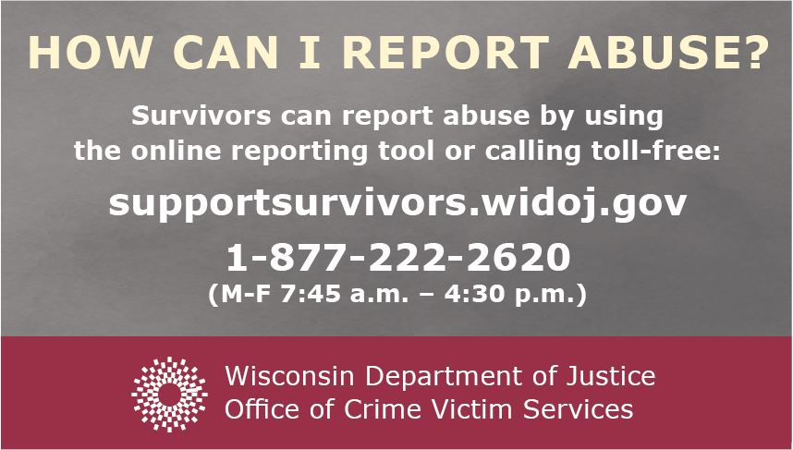

For Instagram
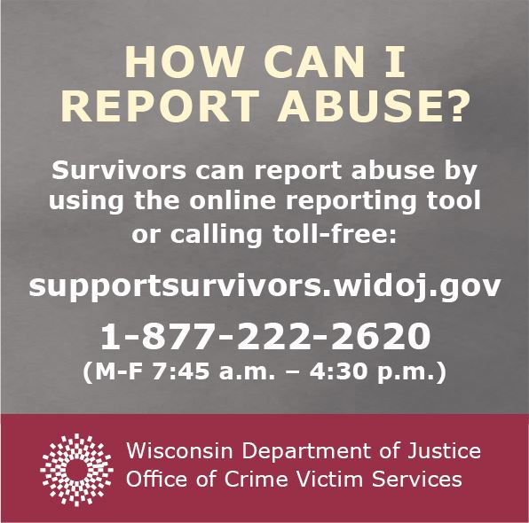

Email / Newsletter Content
The following is sample language to add to your email or print newsletters regarding the DOJ clergy and faith leader abuse initiative:

Attorney General Josh Kaul recently announced a statewide inquiry into clergy and faith leader abuse to provide victims and survivors with an independent review of the sexual abuse committed by clergy and faith leaders in Wisconsin. The Wisconsin Department of Justice encourages anyone who has information about past or current sexual abuse by clergy or faith leaders to report it at: SupportSurvivors.widoj.gov or calling toll-free: 1-877-222-2620 (M-F 7:45 a.m. – 4:30 p.m.).

